DAY 13
Q25: Write a program to implement a basic calculator using switch-case for +, -, *, /, %.
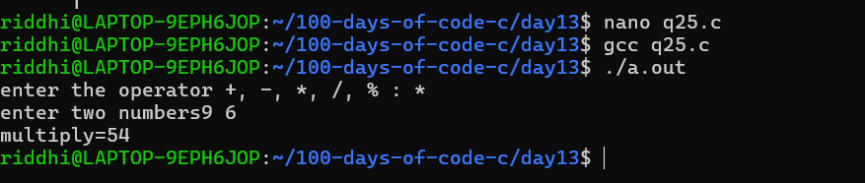

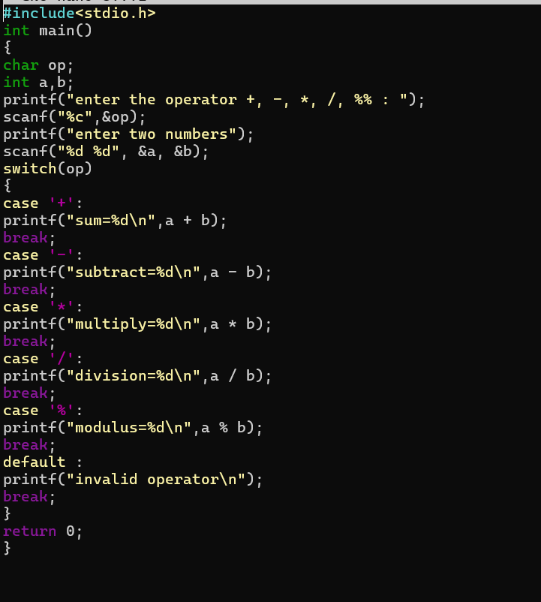

Q26: Write a program to print numbers from 1 to n.

